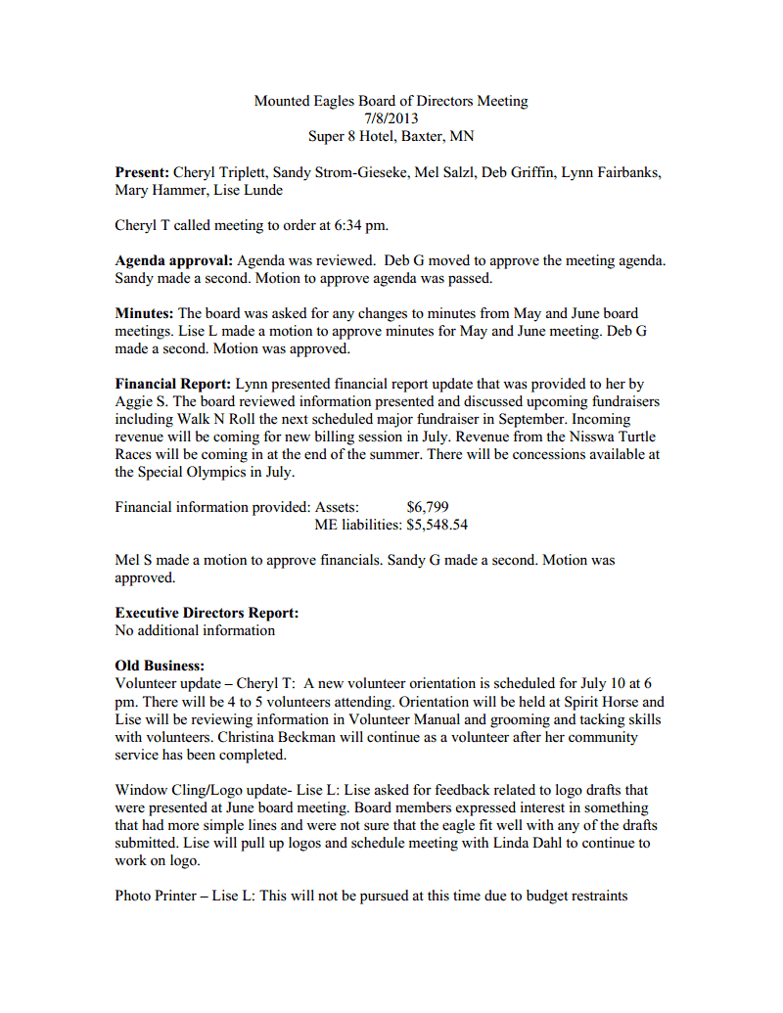

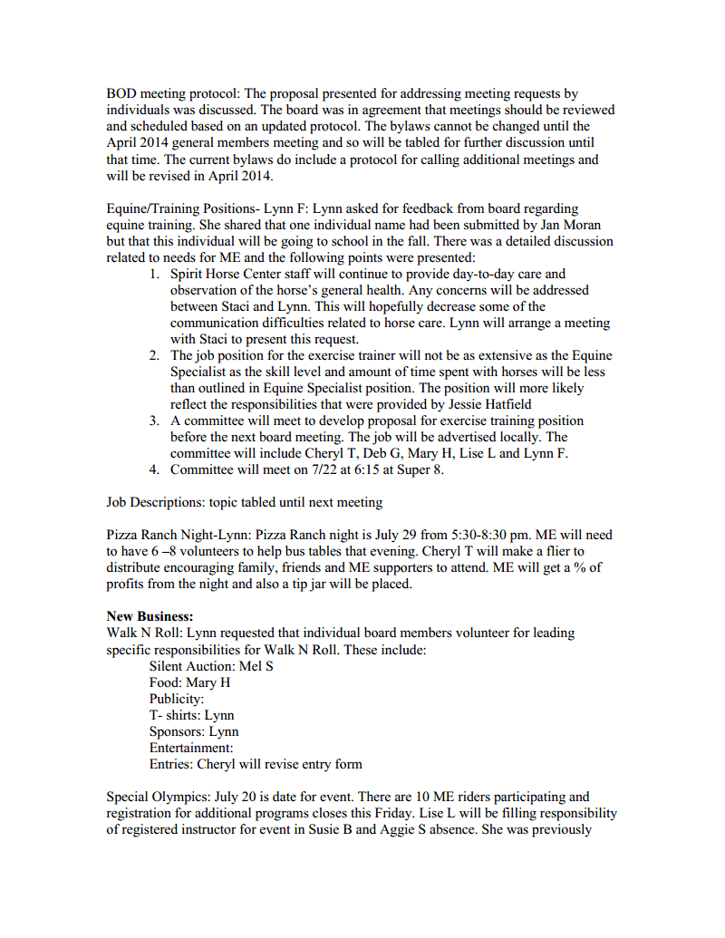

Responsible for concessions and will be talking to Kris Olson and whoever else is interested in assisting with this responsibility.

Hoofin It: Lise will talk to Aggie about advertising event in publication of MN Trail Riders Association.

Winter Wonderland: Lynn presented opportunity for ME to volunteer at event in December. The event is sponsored by Sertoma Club who offers 4 nonprofit groups the opportunity to volunteer 214 hours in preparation and staffing of the event between Aug-Dec. There is a $4000 donation made in exchange for volunteer hours. The board reviewed that schedule and requirements requested and decided not to pursue this activity.

Discovery Horse: Discovery Horse/Sara Sherman offered to organize a Team Building Workshop for Parents and Caregivers of Mounted Eagles participants. The board discussed this opportunity and it was felt that Sara could provide workshop as an option if she is interested. ME would not be officially affiliated with the workshop.

Mel S made a motion to adjourn meeting. Lise L made a second to motion. Meeting was adjourned at 8:45.

The next meeting is scheduled for August 12, 2013.